Press release
Enter, the Netherlands, January 2018
For immediate press release

Coulisse raises awareness of sustainability by taking its employees to the cinema
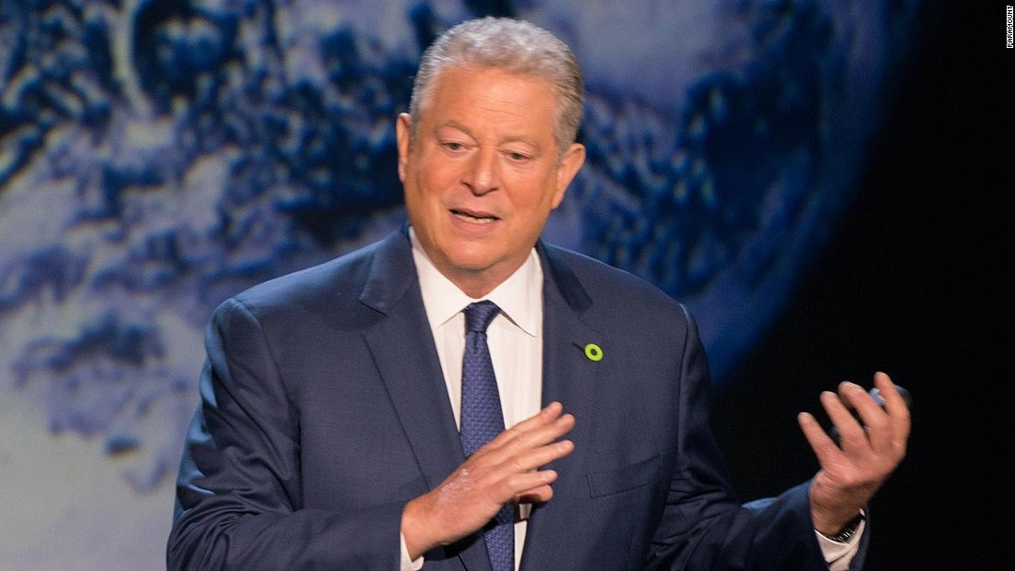

Ten years ago the documentary An Inconvenient Truth brought climate change to the world’s attention. Following the release of the sequel Coulisse has invited its staff, local authorities and the staff of sheltered workshop Blue View to the cinema to watch An Inconvenient Truth II together to raise awareness of sustainability.

Sustainability and corporate social responsibility (CSR) are important pillars of Coulisse’s strategy. To demonstrate its significance, Coulisse has set itself the goal to contribute to

ten out of the seventeen Sustainable Development Goals set by the United Nations. As a result, Coulisse is contributing to the regeneration of the river landscape of the Reggedal

in the Overijssel Region, powers 85% of its locations worldwide with sustainable energy and introduces a roller blind fabric made out of recycled PET bottles.

