Press release
Enter, the Netherlands, October 2017
For immediate press release

New faces in the Coulisse management team
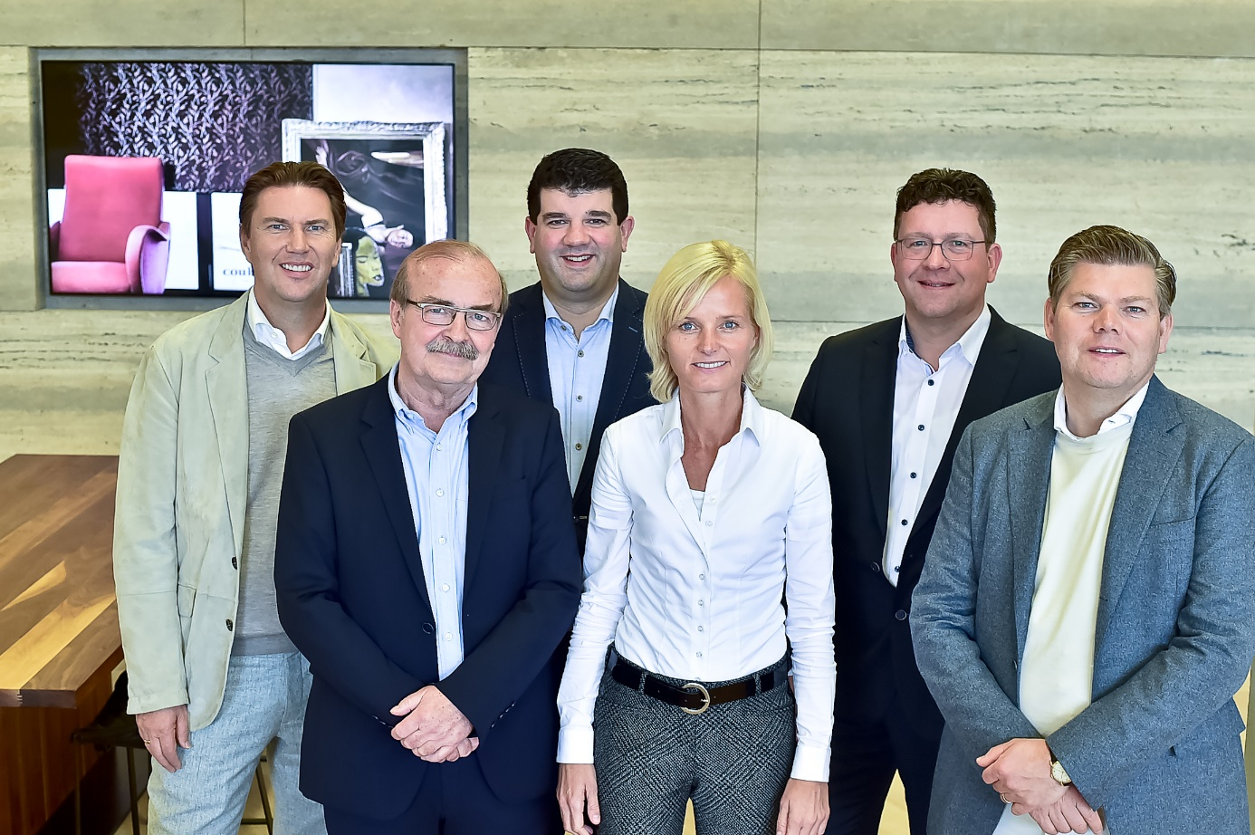
From left to right: Christiaan Roetgering (owner), Klaus Germes (consultant), Hugo Kruijssen (Director Components), Nienke Dusseljee (Director DIY), Rob Boogaard (CEO) and Maurice Roetgering (owner).

As part of the Coulisse growth strategy and following last year’s announcement that Klaus Germes for personal reasons decided to step down as Director Components and will continue working for Coulisse as project consultant, Coulisse has introduced new members to the management team.

New CEO Rob Boogaard is responsible for setting and leading the commercial and operational growth strategy for Coulisse. Owners Christiaan and Maurice Roetgering will, each with his own expertise, remain involved in business operations. Maurice Roetgering will mainly focus on strategic sourcing and partnerships, Christiaan Roetgering will focus on the creative development side of business.

As of 15 June, Coulisse has appointed Hugo Kruijssen as Director Components. In this role, Hugo will focus on further development of activities of the Coulisse made-to-measure division. Prior to joining Coulisse, Hugo was managing director of a large international instore electronics company, for which he was responsible for driving international expansion. Before taking on this position he owned, and later sold, a start-up.

Nienke Dusseljee was appointed Director DIY. Nienke has been working as a sales representative in the do-it-yourself segment for Coulisse for a long time and in her new role is responsible for
further developing and strengthening the Coulisse market position in the worldwide do-it-yourself market.

